MEMORANDUM – OFFICE OF THE TOWN MANAGER
17 Main Street * Lunenburg, MA 01642 * (978) 582-4144
cterenzini@lunenburgma.gov * www.lunenburgma.gov

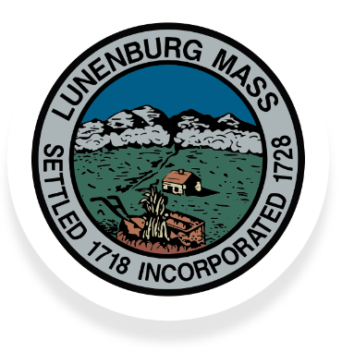
TO: Select Board

FROM: Jennifer Warren-Dyment, Interim Town Manager

RE: Weekly Report

DATE: February 11, 2025

CC: Department Heads; file
______________________________________________________________________________

Project Updates

The Library Teen Room expansion is currently in Phase 1 - two new offices are constructed and painted now. Trim and doors still need to be installed. Phase 2 – teen room expansion is expected to begin next week. This will take about 3 weeks. Lastly, the Children’s story craft room floor is scheduled for replacement this Friday.

During this time, the teen room will be temporarily closed, but teens are invited to hang out in the café area and in the seating area of the library’s main hall. Young adult book collection will be available upon request.

Town Hall Roof Replacement and Chimney Restoration. Again, the weather hasn’t been cooperating for a roofing project and work has been a little slower. 1 chimney is almost complete and then begin work on the 2nd chimney. After that, the same crew will then start the Ritter Memorial Building chimney repairs and continue with the rest of the repair work.

Recruitment

Current vacancies:

- Assistant to the Sewer Business Manager - 19 hours per week. (An interview took place last week with another scheduled for this week)

- Police Chief - The Police Chief applications were due yesterday, and the Assistant Town Manager/HR Director is reviewing all applications received and will be sharing them with the Screening Committee this week.

- Seasonal Lifeguard – up to 40 hours/week during the season

- Seasonal Beach Director – up to 40 hours/week during the season
Grants
- Department of Public Works received a MassDOT grant for $21,953.68 for FY25 Rural Roadways (Chapter 90)
- The Town applied for and was provided funds under the Wellness grant to provide employees with healthy snacks free of charge. This is for all employees of the Town. Great benefit for those working overnights!

Boards and Committee Vacancies:

The current vacancies are:

Agricultural Commission – 1 vacancy
Architectural Preservation District Commission – 1 Vacancy
Board of Health – 1 vacancy
Cultural Council – 1 Vacancy
Finance Committee – 2 Vacancies (interviews conducted this evening)
Green Communities Committee – 2 Vacancies
Historical Commission – 2 Vacancies
Master Plan Steering Committee – 1 Vacancy/2 Representative Vacancies
Personnel Committee – 5 Vacancies
Public Access Cable Committee (PACC) – 1 vacancy
Sewer Commission – 1 Vacancy
Stormwater Task Force – 1 Vacancy
Zoning Board of Appeals – 1 Vacancy

